11.13: In both cases, the tension in the vertical cable is the weight a) Denote the length of the horizontal part of the cable by 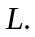 Taking torques about the pivot point, 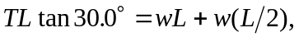from which 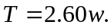 The pivot exerts an upward vertical force of 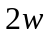 and a horizontal force of 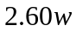, so the magnitude of this force is 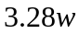, directed 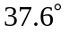 from the horizontal. b) Denote the length of the strut by , and note that the angle between the diagonal part of the cable and the strut is 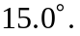 Taking torques about the pivot point, The horizontal force exerted by the pivot on the strut is then 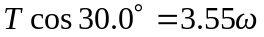 and the vertical force is 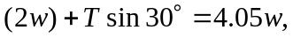 for a magnitude of 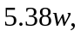 directed 